Web Development Fundamentals Assignment
Name: Vanshika sharma
Batch: 3rd year
Section: AD(65)

1. Difference between Frontend, Backend and Full-stack Development.

Answer: Frontend Development:

Frontend development deals with the user interface of a website or application.

It includes HTML, CSS, and JavaScript.

Example:

Amazon website ka product page jo user dekhta hai, wo frontend ka part hai.

Backend Development:

Backend development handles server-side operations, databases, and application logic.

Example:

Amazon ka order processing system and payment handling backend ka part hai.

Full-stack Development:

Full-stack development includes both frontend and backend development.

Example:

A full-stack developer can create a complete e-commerce website including UI, server, and database.

2.Client-Server Model Diagram

Client
(Browser)
|
|
Request
|
↓
Web Server
|
|
Response
|
↓
Web Page

3.Explain how a browser loads a web page from a server.

1. User enters a website URL in the browser.

2. Browser sends a request to the web server.

3. Server processes the request and sends HTML, CSS and JavaScript files.

4. Browser downloads these files.

5. Browser renders the webpage and displays it to the user.

4.List tools required for web development setup and their uses.

Tool | Purpose
VS Code | Code writing and editing
Browser | Testing websites
Git | Version control
GitHub | Code hosting
Node.js | Running JavaScript outside browser

5.Explain What a Web Server is with Examples.

A web server is software or hardware that stores, processes and delivers web pages to users.

Examples:

1. Apache

2. Nginx

3. Microsoft IIS

6.Explain the roles of frontend developer, backend developer, and database administrator.

Role | Work
Frontend Developer | Creates user interface
Backend Developer | Handles server and logic
Database Administrator | Manages database

7.Install VS Code and configure it for web development with a screenshot.

Visual Studio Code Setup:

Visual Studio Code (VS Code) is a source code editor used for web development. It supports HTML, CSS, and JavaScript development with the help of extensions.
Steps performed:

Installed Visual Studio Code for web development.

Created an HTML file named index.html.

Created CSS and JavaScript files for styling and functionality.

Installed useful extensions:

Live Server

Prettier - Code Formatter

Opened the HTML file using Live Server.

Successfully displayed the "My First Webpage" in the browser.

Screenshot of VS Code Setup:

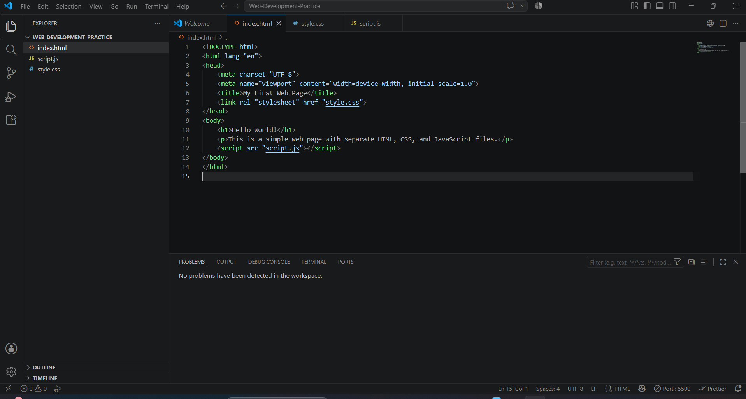

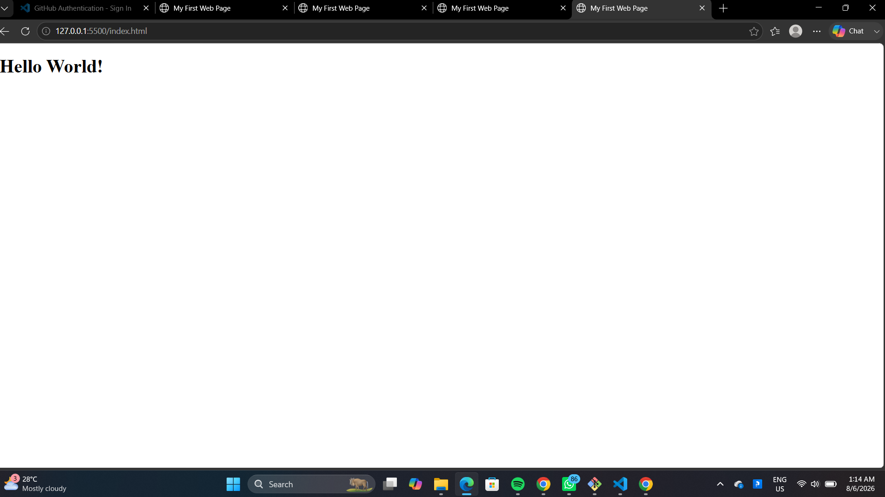

8.Explain static and dynamic websites with examples.

Static Website | Dynamic Website
Fixed content | Content changes
HTML/CSS based | Uses backend and database
Example: Portfolio website | Example: Instagram

9.List five web browsers and their rendering engines.

Browser | Rendering Engine
Chrome | Blink
Firefox | Gecko
Safari | WebKit
Edge | Blink
Opera | Blink

10.Draw a basic web architecture diagram with client, server, database, and APIs.
Client
(Browser)
|
↓
Server
|
↓
API
|
↓
Database

